Form Instructions

Scratch Ticket Sales
This is a daily report in PDF format. This form can be printed and completed manually or electronically.
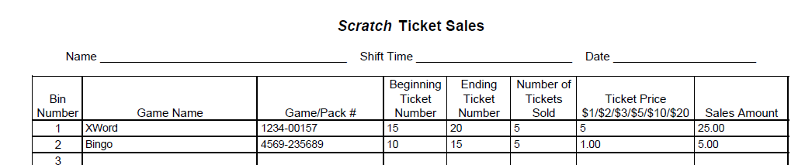
If you sell out of a pack during the day, you will need to add a line to reflect the new pack or put it on the same line with the original pack.
Based on 24 bins.
Shift Manual Tracking Sheet
This is a daily form for those that manage scratch for each shift in Excel format.
It is designed to be done electronically and if you sell out of a pack you can easily add a row to reflect the new pack information.
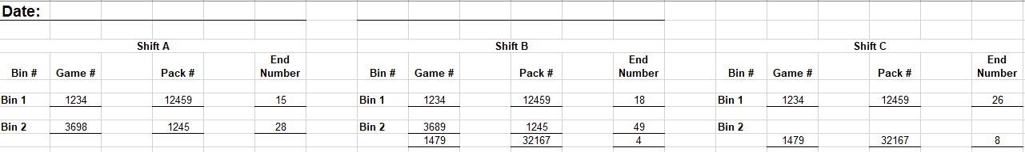
There are tabs on the bottom for 12, 16, 20 and 24 bin dispensers.
There is also an Example tab and one to help balance the Gemini Touch vending machine if applicable.
7-day scratch tracking
This is for those that want to track by the day but have a weekly view in Excel format. The form can be printed on legal-size paper if you do manual tracking.
There is a row to add the initials of the person completing the form by day.
There are tabs on the bottom for 16, 20, 24, and 32 bin dispensers. Tab with an example on how to complete the form.
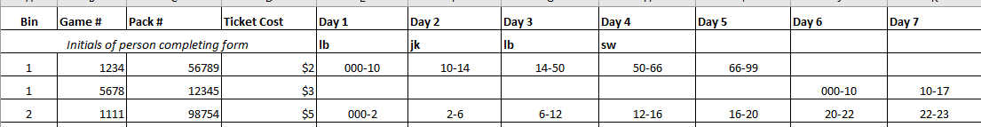
For each day you enter the start and end number for each pack. If you need to add a pack (electronically add a row) if manual add the pack information in the same row for that bin then add the start and end number for the new pack.
On this format there is also a Ticket Cost Legend – provides the value and commission for each price point.

